

**AMERICAN INTERNATIONAL UNIVERSITY-BANGLADESH**

**Course: Introduction to Database Section: M**

# Course Teacher: Md. Sohidul Islum Group No: 5

**Project Title:** **Bus Rapid Transit Management System .**

|  |  |
| --- | --- |
| **Name** | **ID** |
| **Sneha Fairuz Zahin** | **20-41912-1** |
| **Md. Al Amin Chowdhury** | **20-42481-1** |
| **Life Md.Abrar Shariar** | **20-42876-1** |
| **Shakib Sadat Shanto** | **20-43074-1** |
| **Ahmed Munim** | **20-43303-1** |

**Scenario Description:**

Bus Rapid Transit requires a database containing the Passenger, Location, Station, Line, Trip, Bus, Schedule and Ticket. Passenger has passenger_id, first_name, last_name, age, address, phone_number. Passenger buys Ticket. Ticket has ticket_id , bus_no, passenger_id , schedule_id, price, is_business_class, is_normal_class. Bus has Ticket. Bus has bus_no, route_no, bus_type, engine_no. Bus runs on Line. Line has line_id, line_name, departure_station, arrival_station. Line has Station. Station station_id, station_name, division, location_id. Station belongs to Location. Location has location_id, location_name, postal_code, division. Ticket has Schedule. Schedule has schedule_id, trip_id, departure_station_id, journey_date, departure_time, arrival_time. Trip goes by Schedule. Ticket belongs to Schedule.

# E-R DIAGRAM

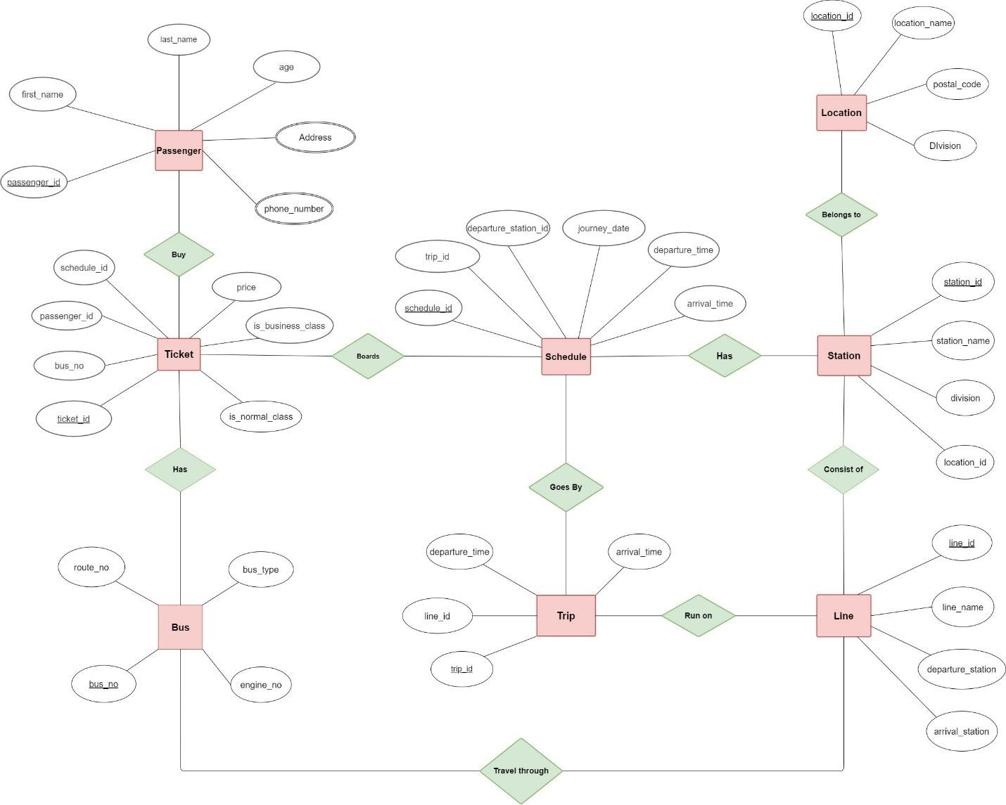

**Normalization**

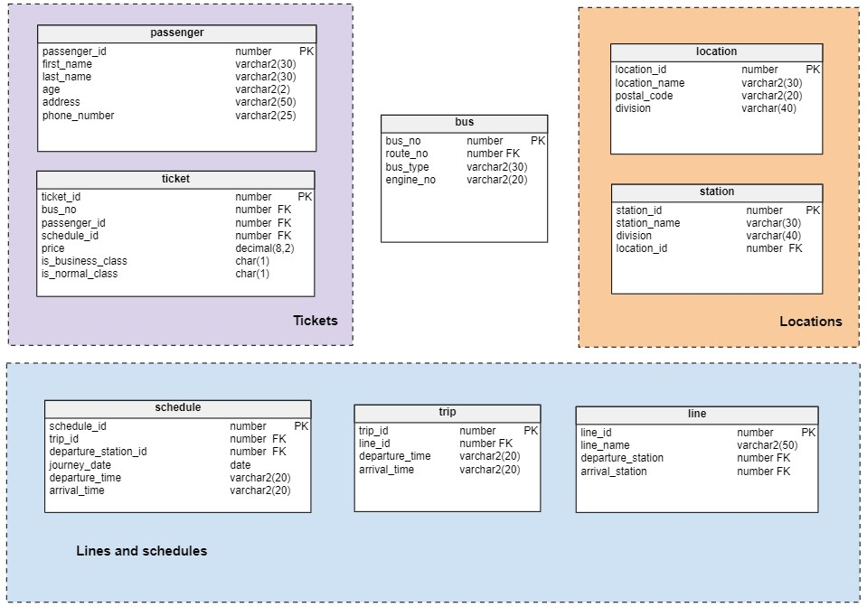

## (Blue -Primary Key & Red- Foreign Key) Location-Station

Contains- (location_id, location_name, postal_code, division, station_id, station_name)

1NF- No multivalued attribute

2NF- 1. location_id, location_name, postal_code, division

2. station_id, station_name, division

Table list-

1. location_id, location_name, postal_code, division
2. station_id, station_name, division, location_id

## Station-Line-Trip-Schedule

Contains- (station_id, station_name, division, line_id, line_name, trip_id, departure_time, arrival_time, schedule_id, journey_date ) 1NF- No multivalued attribute

2NF- 1. station_id, station_name, division

1. line_id, line_name
2. trip_id, departure_time, arrival_time
3. schedule_id, journey_date

Table list-

1. station_id, station_name, division, location_id
2. line_id, line_name, arrival_station, departure_station
3. trip_id, line_id, departure_time, arrival_time
4. schedule_id, departure_time arrival_time, date, trip_id, departure_station_id

## Line-BUS

Contains-( line_id, line_name, bus_no, bus type, engine_no)

1NF. No multivalued attributes

2NF. 1. line_id, line_name

2. bus_no, bus type, engine_no

Table list-

1. line_id, line_name, arrival_station, departure_station
2. bus_no, route_no, bus type, engine_no

## Passenger-Ticket -Bus-Schedule

Contains- (passenger_id , first_name, last_name , age, address, phone_number, ticket_id, price, is_business_class, is_normal_class, bus_no, bus_type, engine_no, schedule_id, journey_date )

1NF. Already Normalized.

2NF. 1. passenger_id , first_name, last_name , age, address, phone_number

1. ticket_id, price, is_business_class, is_normal_class
2. bus_no, bus_type, engine_no
3. schedule_id, journey_date

Table list-

1. passenger_id , first_name, last_name , age, address, phone_number
2. ticket_id, bus_no, passenger_id, price, is_business_class, is_normal_class
3. bus_no, route_no, bus type, engine_no
4. schedule_id, departure_time arrival_time, date, trip_id, departure_station_id

## FINAL TABLE LIST-

1. (Passenger)- passenger_id , first_name, last_name , age, address, phone_number
2. (Location)- location_id, location_name, postal_code, division
3. (Station)- station_id, station_name, division, location_id
4. (Line)- line_id, line_name, arrival_station, departure_station
5. (Trip)- trip_id, line_id, departure_time, arrival_time
6. (Bus)- bus_no, route_no, bus type, engine_no
7. (Schedule)- schedule_id, departure_time arrival_time, date, trip_id, departure_station_id
8. (Ticket)- ticket_id, bus_no, passenger_id, price, is_business_class, is_normal_class

## **TABLE CREATE & DATA INSERT**

**Table – Passenger**

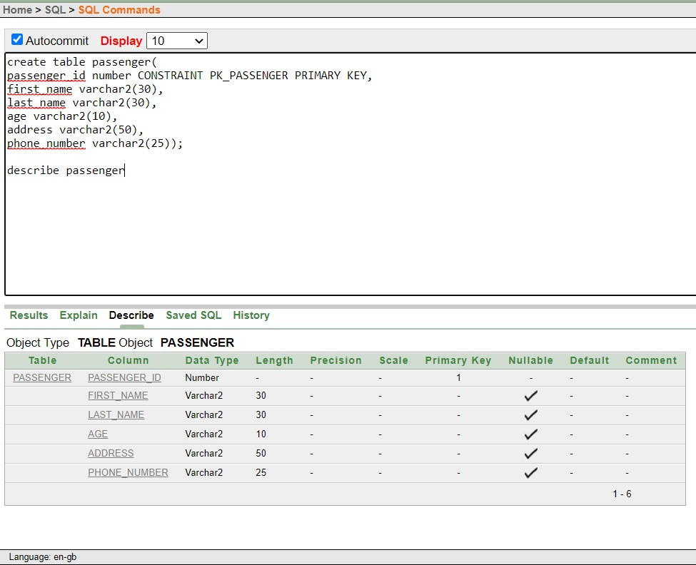

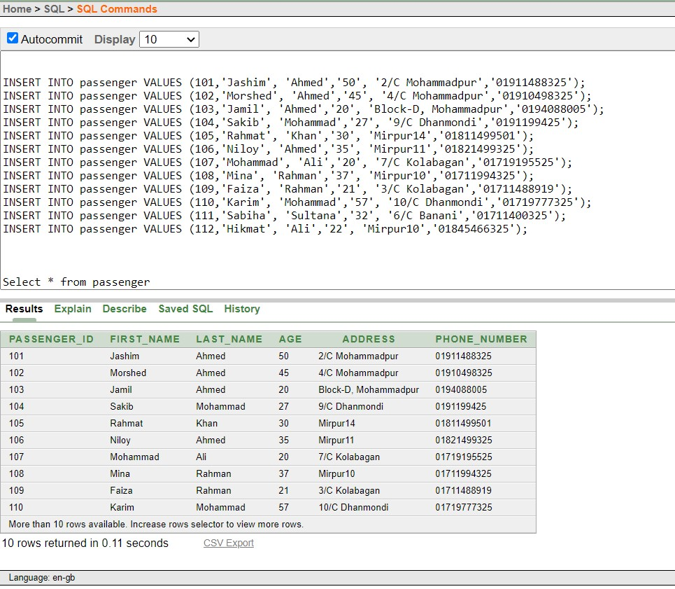

### TABLE- Location

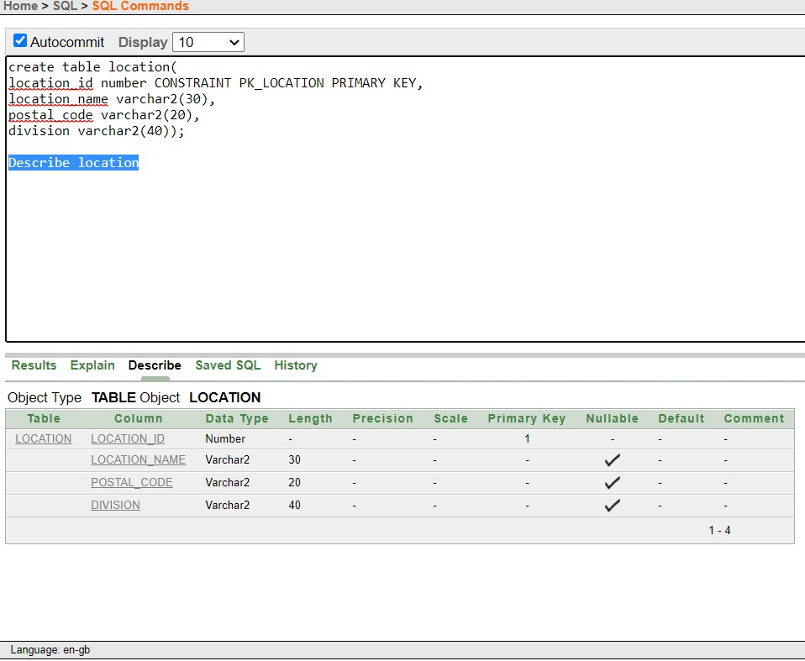

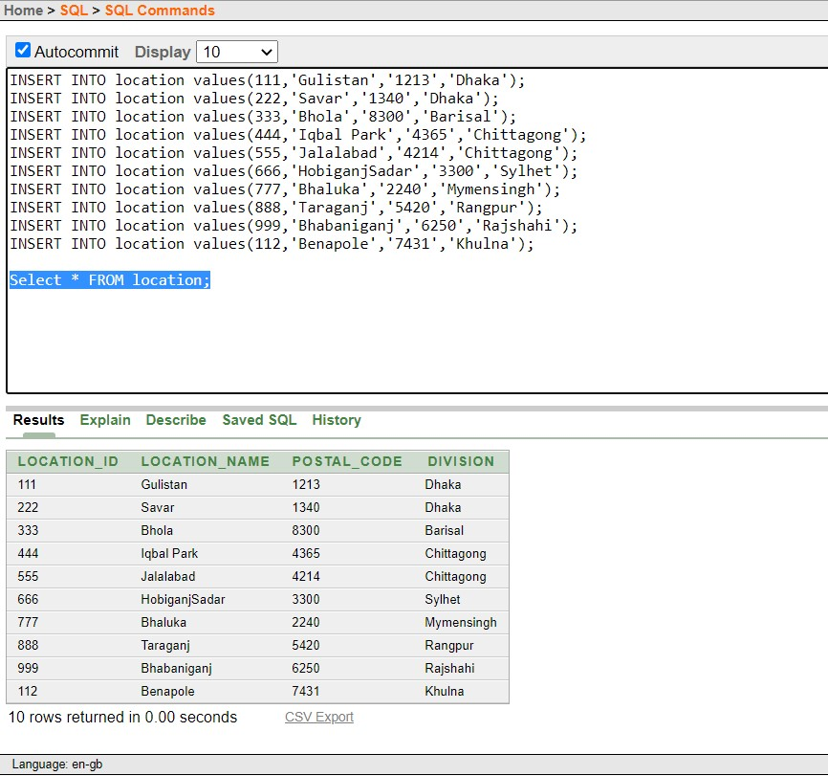

### TABLE-Station

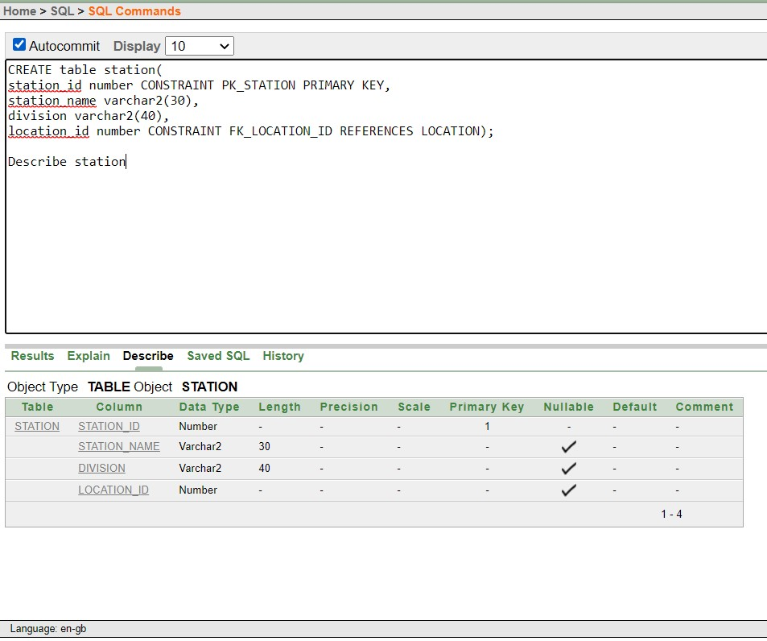

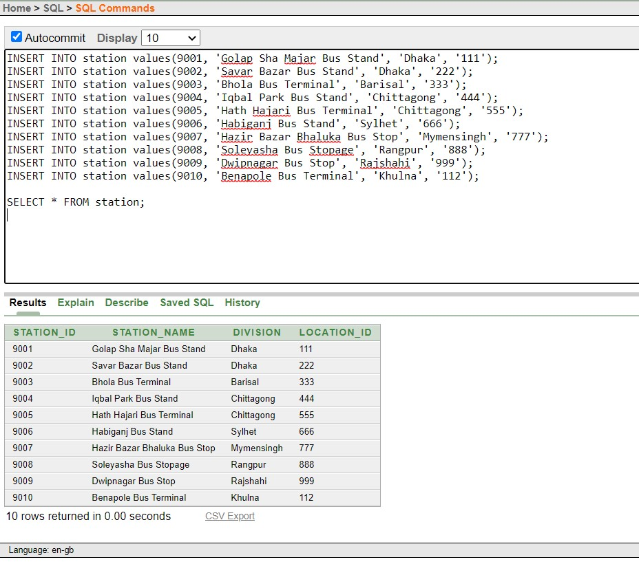

### TABLE-Line

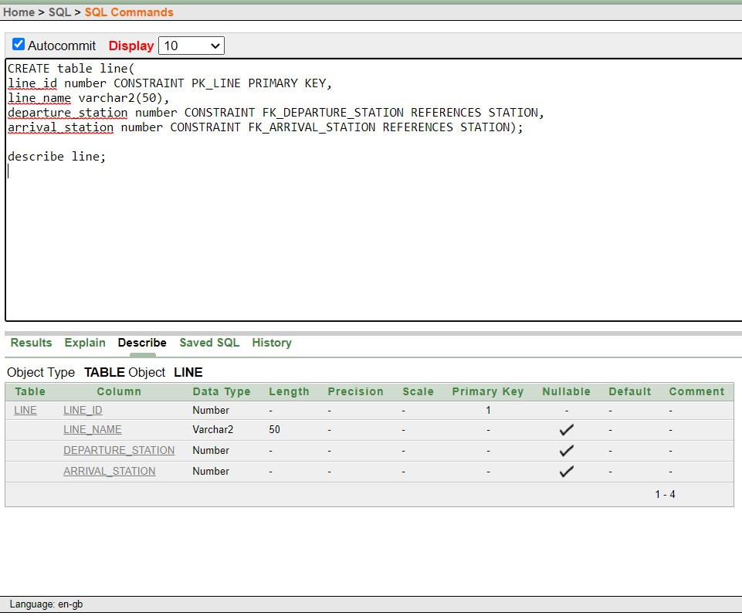

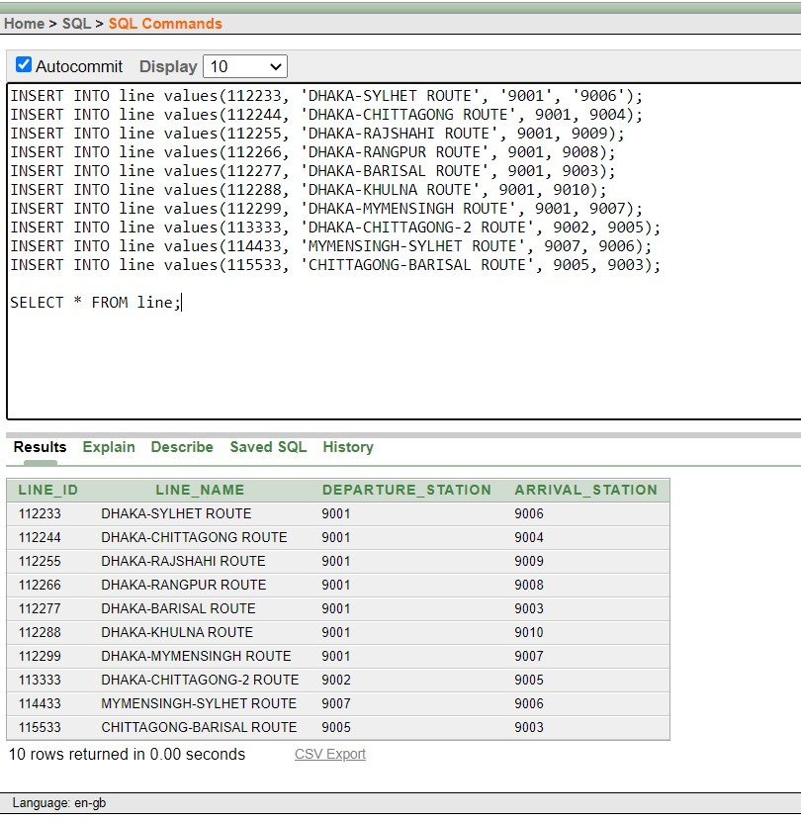

### TABLE-Trip

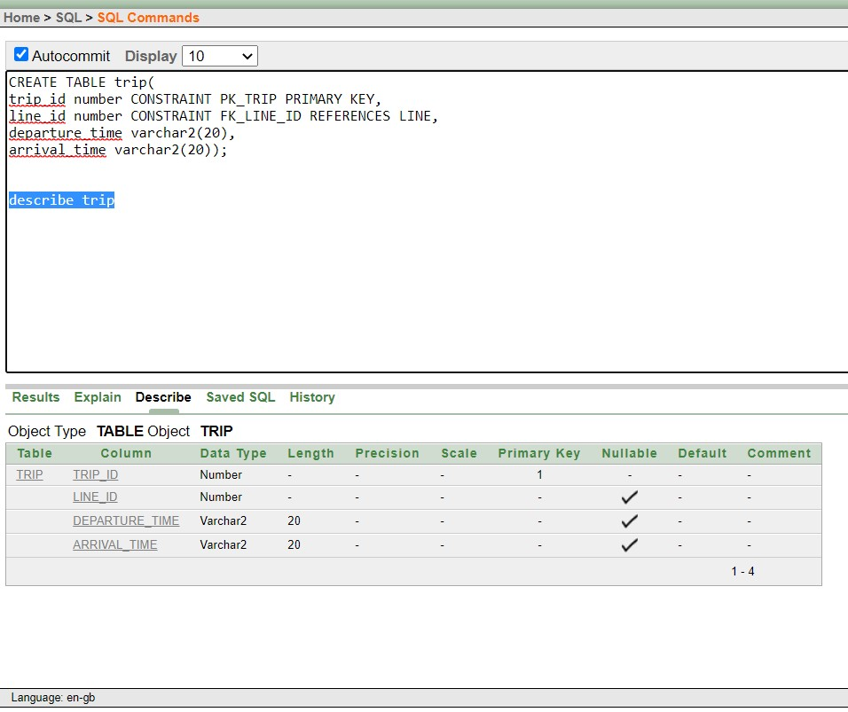

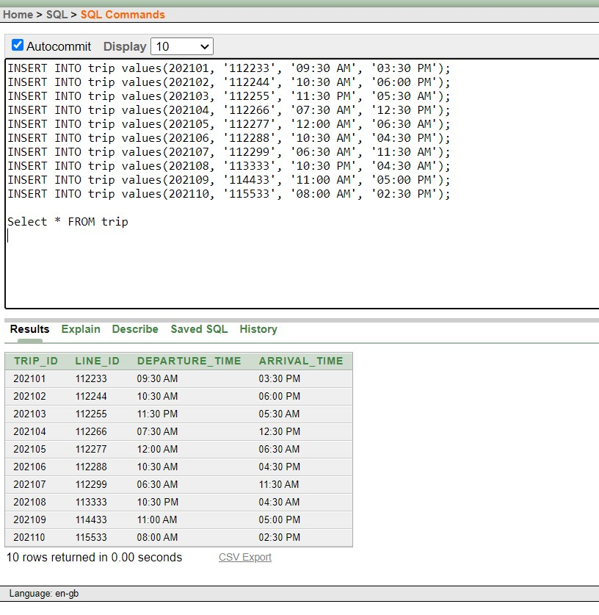

### TABLE- Bus

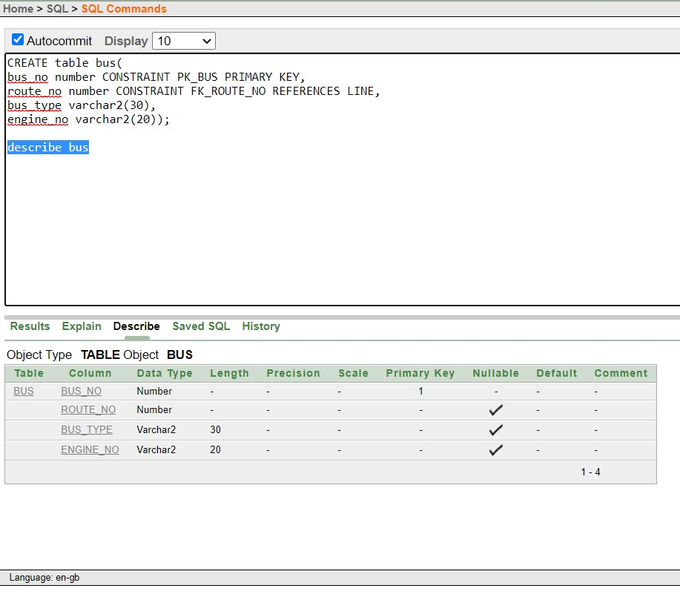

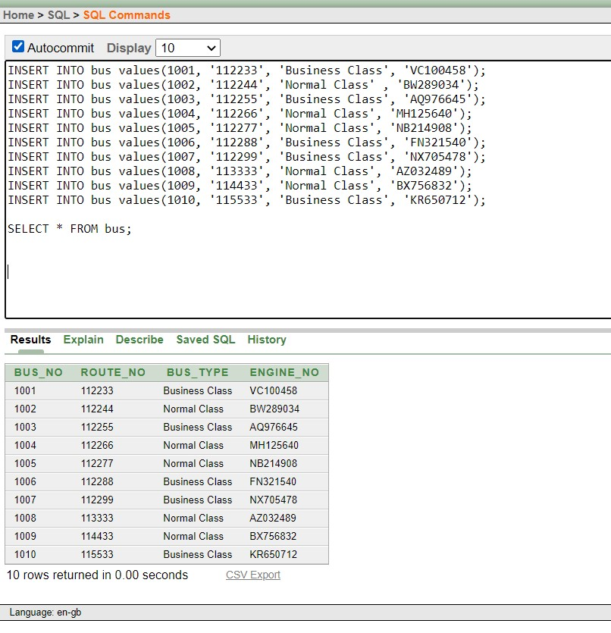

### TABLE- Schedule

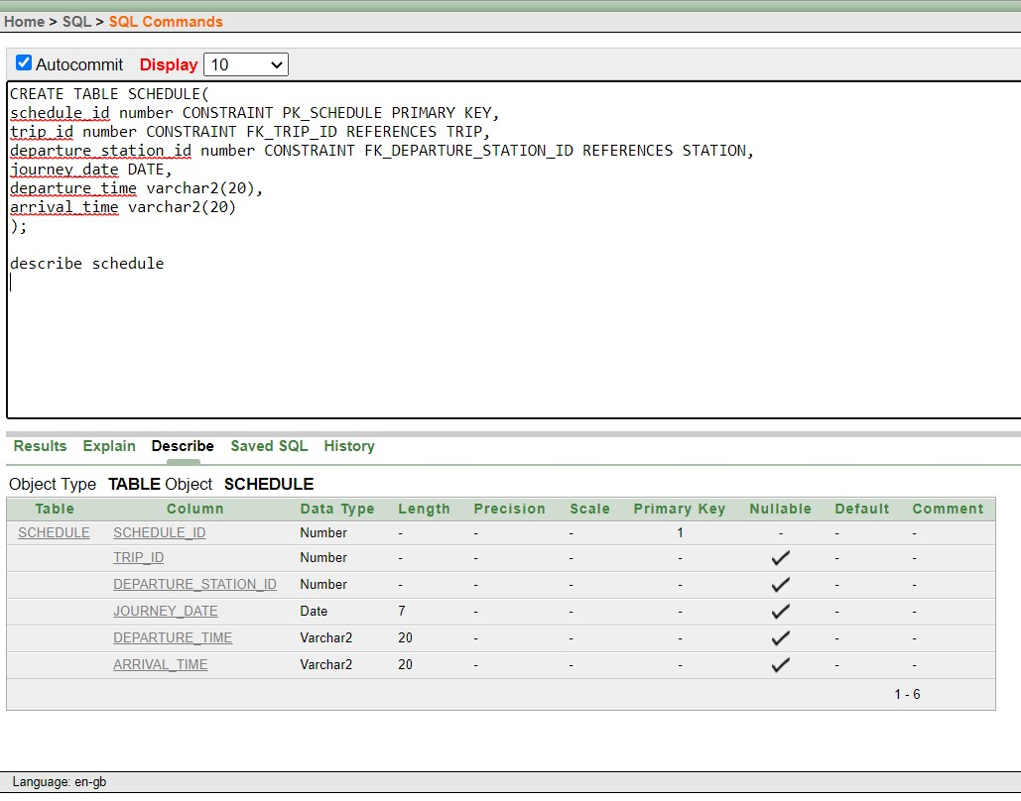

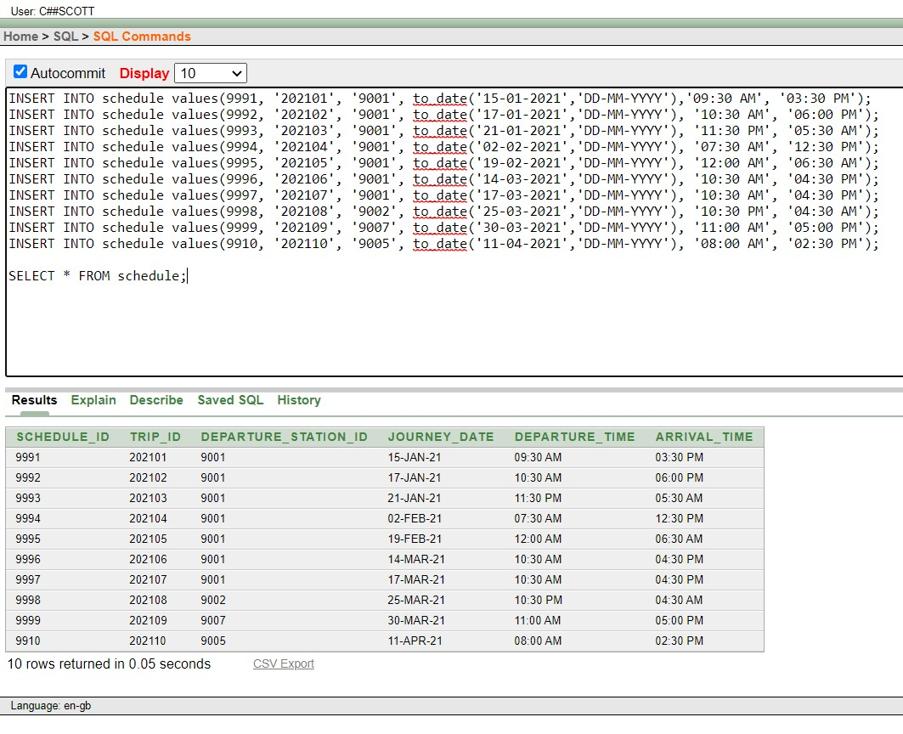

### TABLE- Ticket

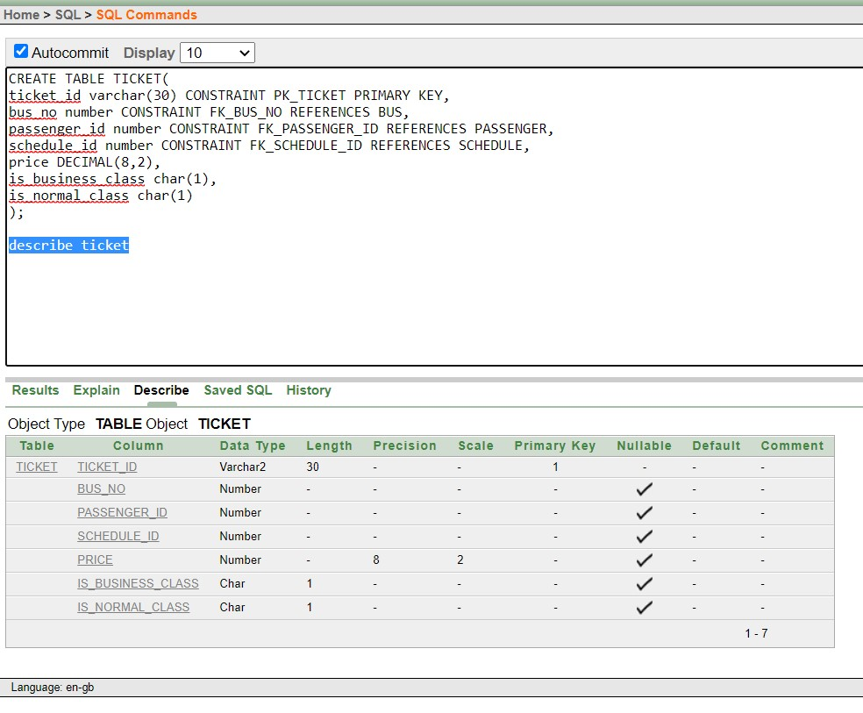

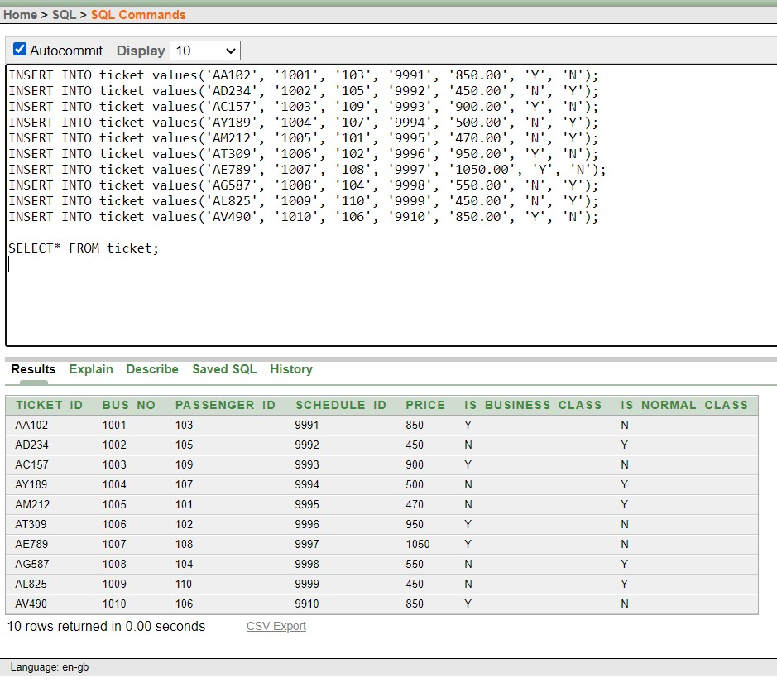

**SOURCE CODE**

### TABLE- Passenger

create table passenger( passenger_id number CONSTRAINT PK_PASSENGER PRIMARY KEY, first_name varchar2(30), last_name varchar2(30), age varchar2(10), address varchar2(50), phone_number varchar2(25));

describe passenger;

INSERT INTO passenger VALUES (101,'Jashim', 'Ahmed','50', '2/C Mohammadpur','01911488325');

INSERT INTO passenger VALUES (102,'Morshed', 'Ahmed','45', '4/C Mohammadpur','01910498325');

INSERT INTO passenger VALUES (103,'Jamil', 'Ahmed','20', 'Block-D, Mohammadpur','0194088005');

INSERT INTO passenger VALUES (104,'Sakib', 'Mohammad','27', '9/C Dhanmondi','0191199425');

INSERT INTO passenger VALUES (105,'Rahmat', 'Khan','30', 'Mirpur14','01811499501');

INSERT INTO passenger VALUES (106,'Niloy', 'Ahmed','35', 'Mirpur11','01821499325');

INSERT INTO passenger VALUES (107,'Mohammad', 'Ali','20', '7/C Kolabagan','01719195525');

INSERT INTO passenger VALUES (108,'Mina', 'Rahman','37', 'Mirpur10','01711994325');

INSERT INTO passenger VALUES (109,'Faiza', 'Rahman','21', '3/C Kolabagan','01711488919');

INSERT INTO passenger VALUES (110,'Karim', 'Mohammad','57', '10/C Dhanmondi','01719777325');

INSERT INTO passenger VALUES (111,'Sabiha', 'Sultana','32', '6/C Banani','01711400325');

INSERT INTO passenger VALUES (112,'Hikmat', 'Ali','22', 'Mirpur10','01845466325'); select * from passenger;

#### TABLE- Location

create table location( location_id number CONSTRAINT PK_LOCATION PRIMARY KEY, location_name varchar2(30), postal_code varchar2(20), division varchar2(40)); describe location;

INSERT INTO location values(111,'Gulistan','1213','Dhaka');

INSERT INTO location values(222,'Savar','1340','Dhaka');

INSERT INTO location values(333,'Bhola','8300','Barisal');

INSERT INTO location values(444,'Iqbal Park','4365','Chittagong');

INSERT INTO location values(555,'Jalalabad','4214','Chittagong');

INSERT INTO location values(666,'HobiganjSadar','3300','Sylhet');

INSERT INTO location values(777,'Bhaluka','2240','Mymensingh');

INSERT INTO location values(888,'Taraganj','5420','Rangpur');

INSERT INTO location values(999,'Bhabaniganj','6250','Rajshahi');

INSERT INTO location values(112,'Benapole','7431','Khulna');

select * from location;

#### TABLE- Station

CREATE table station( station_id number CONSTRAINT PK_STATION PRIMARY KEY, station_name varchar2(30), division varchar2(40), location_id number CONSTRAINT FK_LOCATION_ID REFERENCES LOCATION);

describe station;

INSERT INTO station values(9001, 'Golap Sha Majar Bus Stand', 'Dhaka', '111');

INSERT INTO station values(9002, 'Savar Bazar Bus Stand', 'Dhaka', '222');

INSERT INTO station values(9003, 'Bhola Bus Terminal', 'Barisal', '333');

INSERT INTO station values(9004, 'Iqbal Park Bus Stand', 'Chittagong', '444');

INSERT INTO station values(9005, 'Hath Hajari Bus Terminal', 'Chittagong', '555');

INSERT INTO station values(9006, 'Habiganj Bus Stand', 'Sylhet', '666');

INSERT INTO station values(9007, 'Hazir Bazar Bhaluka Bus Stop', 'Mymensingh', '777');

INSERT INTO station values(9008, 'Soleyasha Bus Stopage', 'Rangpur', '888');

INSERT INTO station values(9009, 'Dwipnagar Bus Stop', 'Rajshahi', '999');

INSERT INTO station values(9010, 'Benapole Bus Terminal', 'Khulna', '112');

SELECT * FROM station;

#### TABLE- Line

CREATE table line( line_id number CONSTRAINT PK_LINE PRIMARY KEY, line_name varchar2(50), arrival_station number CONSTRAINT FK_ARRIVAL_STATION REFERENCES STATION, departure_station number CONSTRAINT FK_DEPARTURE_STATION REFERENCES STATION);

INSERT INTO line values(112233, 'DHAKA-SYLHET ROUTE', '9001', '9006');

INSERT INTO line values(112244, 'DHAKA-CHITTAGONG ROUTE', 9001, 9004);

INSERT INTO line values(112255, 'DHAKA-RAJSHAHI ROUTE', 9001, 9009);

INSERT INTO line values(112266, 'DHAKA-RANGPUR ROUTE', 9001, 9008);

INSERT INTO line values(112277, 'DHAKA-BARISAL ROUTE', 9001, 9003);

INSERT INTO line values(112288, 'DHAKA-KHULNA ROUTE', 9001, 9010);

INSERT INTO line values(112299, 'DHAKA-MYMENSINGH ROUTE', 9001, 9007);

INSERT INTO line values(113333, 'DHAKA-CHITTAGONG-2 ROUTE', 9002, 9005);

INSERT INTO line values(114433, 'MYMENSINGH-SYLHET ROUTE', 9007, 9006);

INSERT INTO line values(115533, 'CHITTAGONG-BARISAL ROUTE', 9005, 9003);

SELECT * FROM line;

#### TABLE- Trip

CREATE TABLE trip( trip_id number CONSTRAINT PK_TRIP PRIMARY KEY, line_id number CONSTRAINT FK_LINE_ID REFERENCES LINE, departure_time varchar2(20), arrival_time varchar2(20));

INSERT INTO trip values(202101, '112233', '09:30 AM', '03:30 PM');

INSERT INTO trip values(202102, '112244', '10:30 AM', '06:00 PM');

INSERT INTO trip values(202103, '112255', '11:30 PM', '05:30 AM');

INSERT INTO trip values(202104, '112266', '07:30 AM', '12:30 PM');

INSERT INTO trip values(202105, '112277', '12:00 AM', '06:30 AM');

INSERT INTO trip values(202106, '112288', '10:30 AM', '04:30 PM');

INSERT INTO trip values(202106, '112288', '10:30 AM', '04:30 PM');

INSERT INTO trip values(202108, '113333', '10:30 PM', '04:30 AM');

INSERT INTO trip values(202109, '114433', '11:00 AM', '05:00 PM'); INSERT INTO trip values(202110, '115533', '08:00 AM', '02:30 PM');

SELECT * FROM trip;

#### TABLE- Bus

CREATE table bus( bus_no number CONSTRAINT PK_BUS PRIMARY KEY, route_no number CONSTRAINT FK_ROUTE_NO REFERENCES LINE, bus_type varchar2(30), engine_no varchar2(20));

describe bus;

INSERT INTO bus values(1001, '112233', 'Business Class', 'VC100458');

INSERT INTO bus values(1002, '112244', 'Normal Class' , 'BW289034');

INSERT INTO bus values(1003, '112255', 'Business Class', 'AQ976645');

INSERT INTO bus values(1004, '112266', 'Normal Class', 'MH125640');

INSERT INTO bus values(1005, '112277', 'Normal Class', 'NB214908');

INSERT INTO bus values(1006, '112288', 'Business Class', 'FN321540');

INSERT INTO bus values(1007, '112299', 'Business Class', 'NX705478');

INSERT INTO bus values(1008, '113333', 'Normal Class', 'AZ032489');

INSERT INTO bus values(1009, '114433', 'Normal Class', 'BX756832');

INSERT INTO bus values(1010, '115533', 'Business Class', 'KR650712');

SELECT * FROM bus;

#### TABLE- Schedule

CREATE TABLE SCHEDULE( schedule_id number CONSTRAINT PK_SCHEDULE PRIMARY KEY, trip_id number CONSTRAINT FK_TRIP_ID REFERENCES TRIP, departure_station_id number CONSTRAINT FK_DEPARTURE_STATION_ID REFERENCES STATION, journey_date DATE, departure_time varchar2(20), arrival_time varchar2(20)

);

describe schedule;

INSERT INTO schedule values(9991, '202101', '9001', to_date('15-01-2021','DD-MM-YYYY'),'09:30 AM', '03:30 PM');

INSERT INTO schedule values(9992, '202102', '9001', to_date('17-01-2021','DD-MM-YYYY'), '10:30 AM', '06:00 PM');

INSERT INTO schedule values(9993, '202103', '9001', to_date('21-01-2021','DD-MM-YYYY'), '11:30 PM', '05:30 AM');

INSERT INTO schedule values(9994, '202104', '9001', to_date('02-02-2021','DD-MM-YYYY'), '07:30 AM', '12:30 PM');

INSERT INTO schedule values(9995, '202105', '9001', to_date('19-02-2021','DD-MM-YYYY'), '12:00 AM', '06:30 AM');

INSERT INTO schedule values(9996, '202106', '9001', to_date('14-03-2021','DD-MM-YYYY'), '10:30 AM', '04:30 PM');

INSERT INTO schedule values(9997, '202107', '9001', to_date('17-03-2021','DD-MM-YYYY'), '10:30 AM', '04:30 PM');

INSERT INTO schedule values(9998, '202108', '9002', to_date('25-03-2021','DD-MM-YYYY'), '10:30 PM', '04:30 AM');

INSERT INTO schedule values(9999, '202109', '9007', to_date('30-03-2021','DD-MM-YYYY'), '11:00 AM', '05:00 PM');

INSERT INTO schedule values(9910, '202110', '9005', to_date('11-04-2021','DD-MM-YYYY'), '08:00 AM', '02:30 PM');

SELECT * FROM schedule;

#### TABLE- Ticket

CREATE TABLE TICKET( ticket_id varchar(30) CONSTRAINT PK_TICKET PRIMARY KEY, bus_no number CONSTRAINT FK_BUS_NO REFERENCES BUS, passenger_id number CONSTRAINT FK_PASSENGER_ID REFERENCES PASSENGER, schedule_id number CONSTRAINT FK_SCHEDULE_ID REFERENCES SCHEDULE, price DECIMAL(8,2), is_business_class char(1), is_normal_class char(1)

);

describe ticket;

INSERT INTO ticket values('AA102', '1001', '103', '9991', '850.00', 'Y', 'N');

INSERT INTO ticket values('AA102', '1002', '105', '9992', '450.00', 'N', 'Y');

INSERT INTO ticket values('AA102', '1003', '109', '9993', '900.00', 'Y', 'N');

INSERT INTO ticket values('AA102', '1004', '107', '9994', '500.00', 'N', 'Y');

INSERT INTO ticket values('AA102', '1005', '101', '9995', '470.00', 'N', 'Y');

INSERT INTO ticket values('AA102', '1006', '102', '9996', '950.00', 'Y', 'N');

INSERT INTO ticket values('AA102', '1007', '108', '9997', '1050.00', 'Y', 'N');

INSERT INTO ticket values('AA102', '1008', '104', '9998', '550.00', 'N', 'Y');

INSERT INTO ticket values('AA102', '1009', '110', '9999', '450.00', 'N', 'Y'); INSERT INTO ticket values('AA102', '1010', '106', '9910', '850.00', 'Y', 'N');

INSERT INTO ticket values('AA102', '1001', '103', '9991', '850.00', 'Y', 'N');

INSERT INTO ticket values('AD234', '1002', '105', '9992', '450.00', 'N', 'Y');

INSERT INTO ticket values('AC157', '1003', '109', '9993', '900.00', 'Y', 'N');

INSERT INTO ticket values('AY189', '1004', '107', '9994', '500.00', 'N', 'Y');

INSERT INTO ticket values('AM212', '1005', '101', '9995', '470.00', 'N', 'Y');

INSERT INTO ticket values('AT309', '1006', '102', '9996', '950.00', 'Y', 'N');

INSERT INTO ticket values('AE789', '1007', '108', '9997', '1050.00', 'Y', 'N');

INSERT INTO ticket values('AG587', '1008', '104', '9998', '550.00', 'N', 'Y');

INSERT INTO ticket values('AL825', '1009', '110', '9999', '450.00', 'N', 'Y');

INSERT INTO ticket values('AV490', '1010', '106', '9910', '850.00', 'Y', 'N');

SELECT* FROM ticket;

## **IMPORTANT QUERIES**

### Comparison-

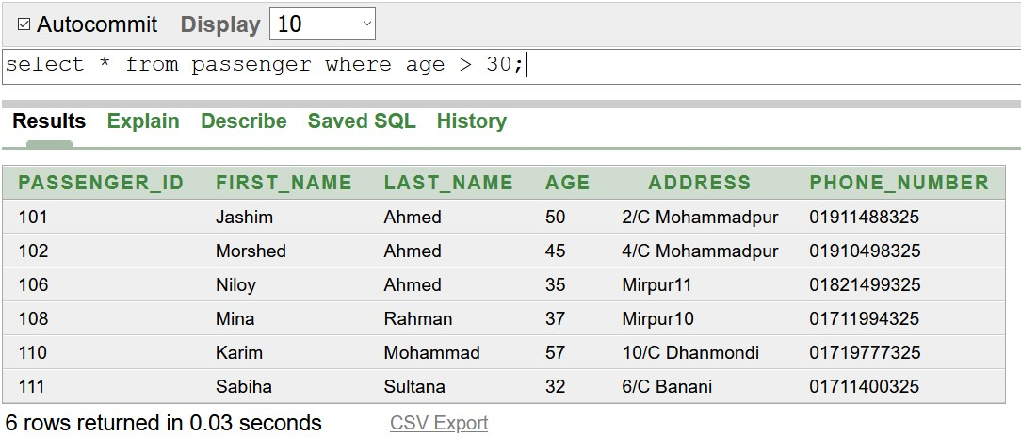

### Limiting Row-

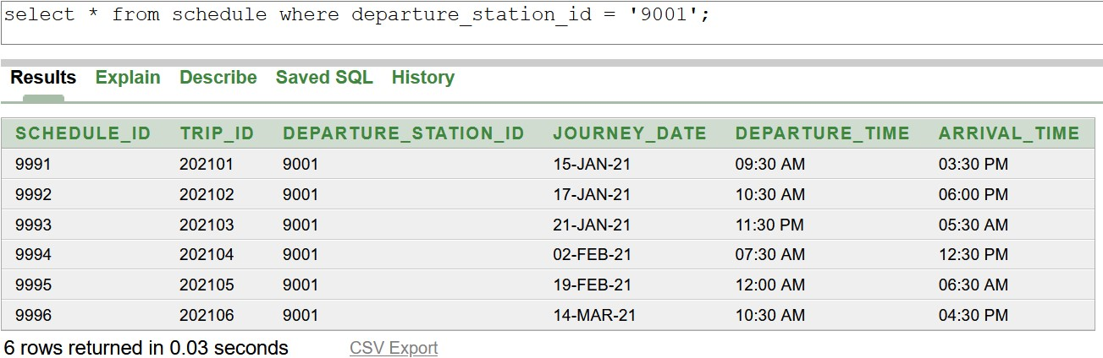

### Logical Operators-

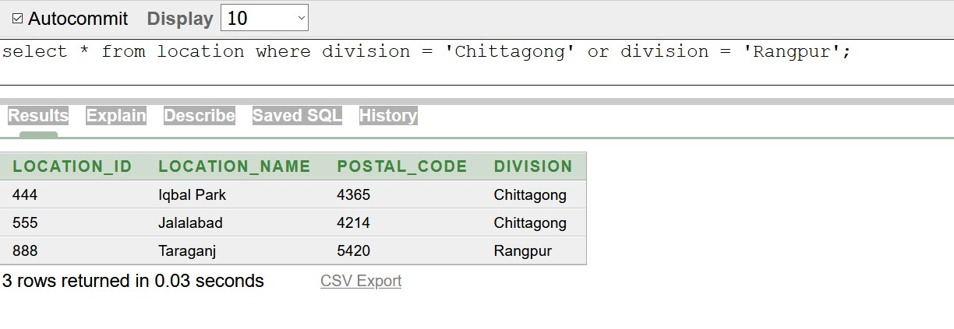

**Multiple Row Subqueries-**

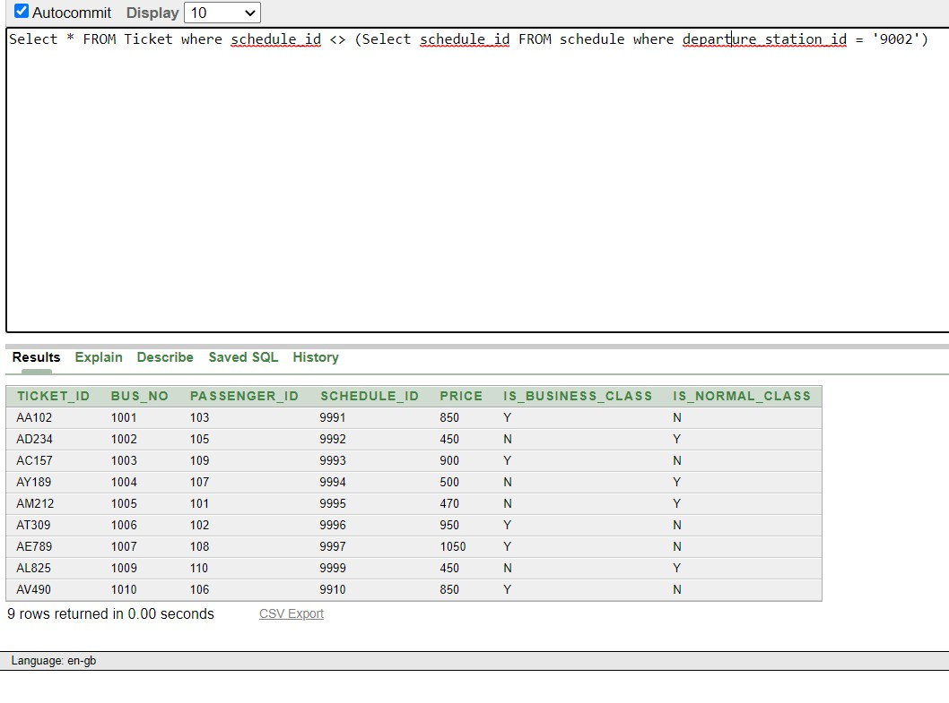

### Joining Query-

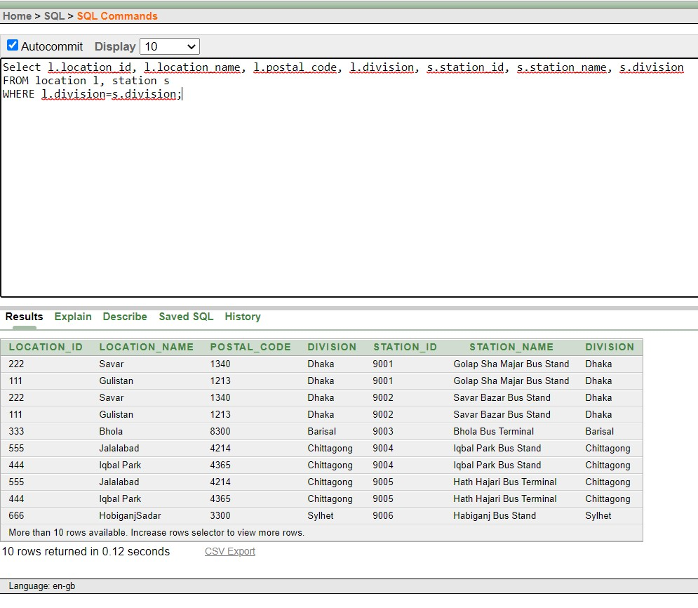

### VIEW Query-

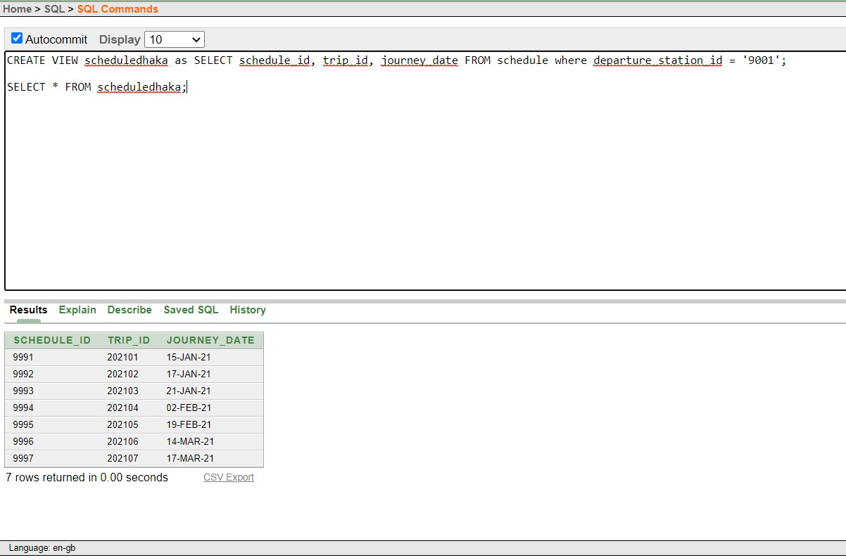

## Conclusion

This project helped us to understand how to store data in various table and join them. Moreover, it also helped to design a database model while maintain relations between different tables, modify them and retrieve them. We think this project will help us in future to do more database related works.

# THANK YOU